# The Ultimate Battleships: Fight for Destiny

**Date:** 14/9/2017

**Student Names:** Rauf Nawaz Tarar Sultana, Archie Rutherford, Alfie Hippisley, Frantisek Pavlica

## Statement of requirements

A program to play a game of Battleships; a game where the user attempts to guess where the enemy's ships are on a grid, and shoot them down.

The users should have some computer knowledge but will not need to be very advanced to play this game. The user should be able to use a keyboard and mouse.

Inputs

* Coordinates from Keyboard.
* Username from Keyboard.
* Mouse input to navigate menu and settings.

Outputs

* Display Menu.
* Display Game Board showing hits and misses.
* Display Leader Board.

### Requirements

**Functional Requirements**

* The game shall start on a menu where the user can select different options.
  + There shall be a start game button which shall start a new game with the settings that are selected.
    - The computer shall randomly generate a fleet of ships on a grid.
    - The standard fleet shall contain:
      * 1 Battleship (4 spaces)
      * 2 Cruisers (3 spaces)
      * 3 Destroyers (2 spaces)
      * 3 Submarines (1 space)
    - The program shall get coordinates from the user and check if there is a battleship in this position.
      * If one of the generated ships sit in the position the user has chosen then the program shall indicate that the user has hit a ship.
      * If there is no ship in the user's indicated position then it shall register as a miss.
    - If the user has hit all of the spaces that the computer's ship occupies then the user shall be told that they have sunk this ship.
    - When the user has sunk the computer's whole fleet then the game shall end.
    - The computer will ask for a name and then tell the user how many shots they fired in total (includes hits and misses).
    - The computer may then display the leader board.
      * The leader board may consist of the top 5 highest scores and the username for who achieved them.
  + There shall be a settings button which will take the user to another menu to adjust the game's properties.
    - There may be an option to change the size of the grid which may make it easier (a smaller grid) or harder (a larger grid).
    - There may be an option to change the fleet size.
    - There may be an option to limit the number of turns allowed for shooting down ships.
    - There may be an option to change the colour of the background.
    - There should be an option to quit the game.
  + There shall be save game and load game buttons, which shall save or load the state of the current game to or from a text file, respectively.

**Non-functional Requirements**

* The program should be usable on virtually all desktop computers which support Java.
* The game should be intuitive and well structured.
* The text should be easy to read.
* The game should be quick to load.
* The graphics should look consistent.
* The game should be fun to play.
* The game should take about a minute to complete.

### User Interface

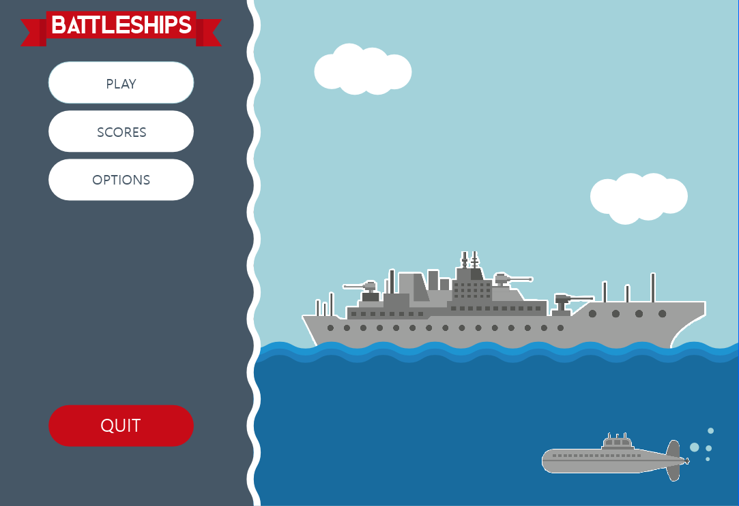

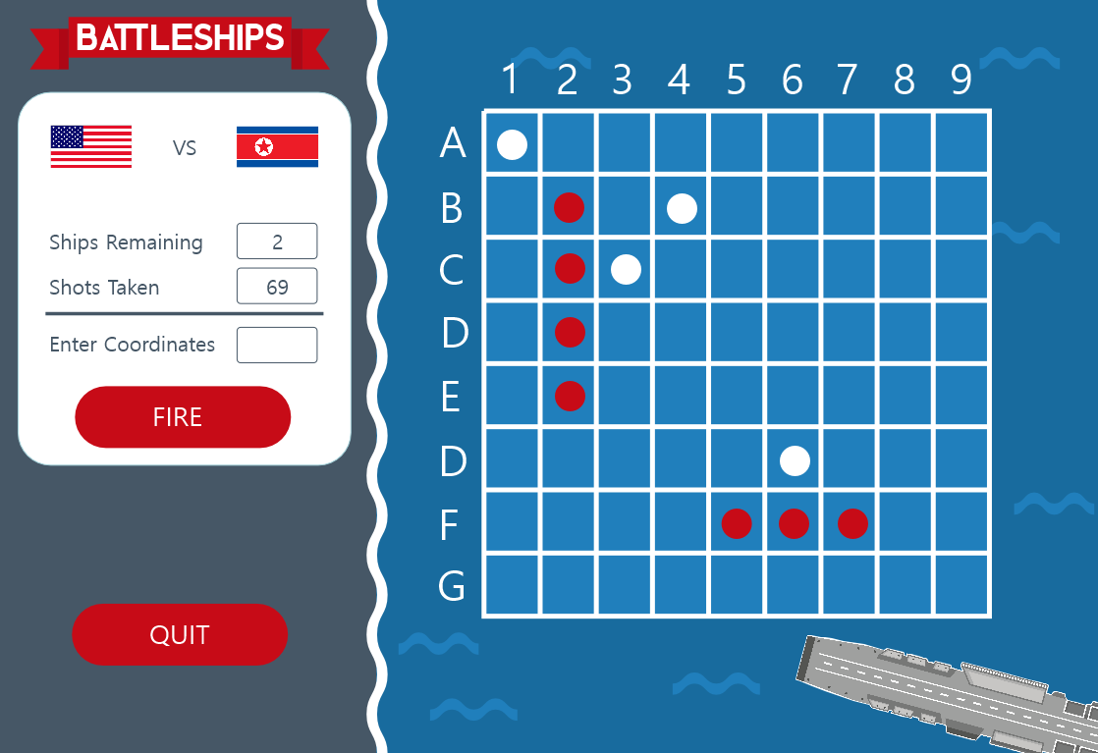

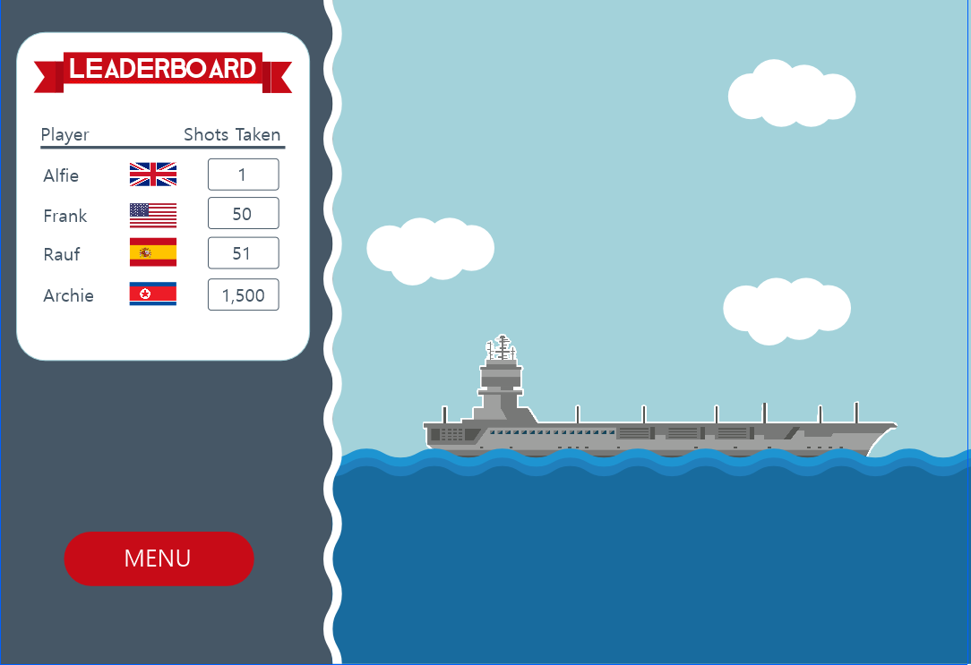

### Use Cases

|  |  |  |  |
| --- | --- | --- | --- |
| New Game | | | Alternatives |
| 1 | System | Loads the **menu** with all of the **buttons** on it. |  |
| 2 | User | Press the"New Game" **button**. |  |
| 3 | System | Loads an empty **Game Board** with the Game Settings selected. |  |
| 4 | System | Asks the **user** for a **coordinate** to fire a **shot** at. |  |
| 5 | User | Enters a **coordinate**. | Alternative 1 |
| 6 | System | Displays a **message** saying the **user** has hit a **ship**. | Alternative 2 |
| 7 | System | Check whether the **user** has destroyed a **ship**. |  |
| 8 | System | Display a **message** saying the **user** has destroyed a **ship** and what kind it is. |  |
| 9 | System | Check if all the **ships** are destroyed. | Alternative 3 |
| 10 | System | Check how many **shots** were fired. |  |
| 11 | System | Display a **message** saying "You saved the **world** in " + **number of shots fired** + " shots!" |  |
| 12 | System | Check if the **number of shots** is less than **last place** in the **leader board**. | Alternative 4 |
| 13 | System | Ask the **user** for a **username**. |  |
| 14 | User | Enter a **username**. |  |
| 15 | System | Check it is a valid **username**. | Alternative 5 |
| 16 | System | Display the updated **leader board**. |  |
|  | | | |
| Load Game | | | **Alternatives** |
| 1 | System | Loads the **menu** with all of the **buttons** on it. |  |
| 2 | User | Press the"Load Game" **button**. |  |
| 3 | System | Looks for the **Game Save file**. |  |
| 4 | System | Loads the **Game Board** with all of the data from the last saved game on it. | Alternative 6 |
| 5 | System | Return to Step 4 of New Game flow |  |

|  |  |  |  |
| --- | --- | --- | --- |
| Change Grid Size | | | Alternatives |
| 1 | System | Loads the **menu** with all of the **buttons** on it. |  |
| 2 | User | Press the"Options" **button**. |  |
| 3 | System | Loads another **menu** with **settings** that can be changed. |  |
| 4 | User | Changes the “**Grid Size**” to a valid **size**. | Alternative 7 |
| 5 | System | Display a **message** saying “If you change the **grid size** your saved **game** will be deleted.” |  |
| 6 | System | Ask if the **user** would still like to continue. |  |
| 7 | User | Presses “Yes” to change it. | Alternative 8 |
| 8 | System | Change the **Grid Size** in the **Game Settings**. |  |
| 9 | System | Return to Step 3. |  |

|  |  |  |  |
| --- | --- | --- | --- |
| Change Fleet Size | | | Alternatives |
| 1 | System | Loads the **menu** with all of the **buttons** on it. |  |
| 2 | User | Press the"Options" **button**. |  |
| 3 | System | Loads another **menu** with **settings** that can be changed. |  |
| 4 | User | Changes the “**Fleet Size**” to a valid **size**. | Alternative 9 |
| 5 | System | Display a **message** saying “If you change the fleet size your saved game will be deleted.” |  |
| 6 | System | Ask if the **user** would still like to continue. |  |
| 7 | User | Presses “Yes” to change it. | Alternative 10 |
| 8 | System | Change the **Fleet Size** in the **Game Settings**. |  |
| 9 | System | Return to Step 3. |  |

|  |  |  |  |
| --- | --- | --- | --- |
| Change Background Colour | | | Alternatives |
| 1 | System | Loads the **menu** with all of the **buttons** on it. |  |
| 2 | User | Press the"Options" **button**. |  |
| 3 | System | Loads another **menu** with **settings** that can be changed. |  |
| 4 | User | Change the **background colour** to one of the **possible colours**. |  |
| 5 | System | Change the **Background Colour** in the **Game Settings**. |  |
| 6 | System | Return to Step 3. |  |

|  |  |  |
| --- | --- | --- |
| Alternative 1 | | |
| 1 | User | Enters an Invalid coordinate. |
| 2 | System | Display a message saying the coordinate is invalid |
| 3 | System | Return to New Game Flow Step 4 |

|  |  |  |
| --- | --- | --- |
| Alternative 2 | | |
| 1 | System | Displays a message saying the user hasn’t hit a ship. |
| 2 | System | Return to New Game Flow Step 4 |

|  |  |  |
| --- | --- | --- |
| Alternative 3 | | |
| 1 | System | Return to New Game Flow Step 4 |

|  |  |  |
| --- | --- | --- |
| Alternative 4 | | |
| 1 | System | Displays a message saying “You didn’t make the leader board this time.” |
| 2 | System | Return to New Game Flow Step 16 |

|  |  |  |
| --- | --- | --- |
| Alternative 5 | | |
| 1 | System | Displays a message saying “This is an invalid Username.” |
| 2 | System | Return to New Game Flow Step 14 |

|  |  |  |
| --- | --- | --- |
| Alternative 6 | | |
| 1 | System | Display a message saying “There is no currently saved game.” |
| 2 | System | Return to New Game Flow Step 1 |

|  |  |  |
| --- | --- | --- |
| Alternative 7 | | |
| 1 | System | Displays a message saying “This is an invalid size.” |
| 2 | System | Return to Change Grid Size Flow Step 3 |

|  |  |  |
| --- | --- | --- |
| Alternative 8 | | |
| 1 | User | Presses “No” to keep the changes the same. |
| 2 | System | Return to Change Grid Size Flow Step 3 |

|  |  |  |
| --- | --- | --- |
| Alternative 9 | | |
| 1 | System | Displays a message saying “This is an invalid size.” |
| 2 | System | Return to Change Fleet Size Flow Step 3 |

|  |  |  |
| --- | --- | --- |
| Alternative 10 | | |
| 1 | User | Presses “No” to keep the changes the same. |
| 2 | System | Return to Change Fleet Size Flow Step 3 |

### Classes

##### Candidate Classes

|  |  |  |
| --- | --- | --- |
| Candidate Classes | Accept / Reject | Reason for rejection |
| Menu | Reject | Irrelevant. |
| Buttons | Reject | Plural. |
| Button | Accept | Holds information about a button. |
| Game Board | Accept | Holds information about the Game Board. |
| User | Accept | Holds information about the User. |
| Coordinate | Reject | Irrelevant. |
| Shot | Reject | Irrelevant. |
| Message | Reject | Irrelevant. |
| Ship | Accept | Holds information about a ship. |
| Ships | Reject | Plural. |
| Number of Shots Fired | Reject | It's a field. (User) |
| Last Place | Reject | Too Vague. |
| Leader Board | Accept | Holds information about the Leader Board. |
| Username | Reject | It's a field. (User) |
| Settings | Reject | Plural. |
| Setting | Reject | Irrelevant. |
| Grid Size | Reject | It's a Field. (Game Board) |
| Size | Reject | Too Vague. |
| Game Settings | Reject | Same as Setting. |
| Fleet Size | Accept | Holds information about the size of the enemy fleet. |
| Background Colour | Reject | It's a Field. (Game Board) |
| Possible Colours | Reject | Irrelevant. |
| World | Reject | Irrelevant. |
| Game Save File | Reject | It's a file. |
| Game | Reject | Irrelevant. |

##### Class Descriptions including Responsibilities, Fields and Methods

* Game
  + + fireShot()
  + + checkRemainingShips()
  + + loadBoard()
  + + saveGame()
* Button
  + - Position (Array, Integer)
  + - Text (String)
  + - Size (Array, Integer)
  + + showText()
* Game Board
  + - Grid Size (Array, Integer)
  + - Background Colour (Array, Real)
  + + showSize()
  + + showColour()
* User
  + - Username (String)
  + - Shots Fired (Integer)
* Ship
  + - Start Position (String)
  + - Rotation (Boolean)
  + - Length (Integer)
* Leader Board
  + - Username (String)
  + - Place (Integer)
  + + showName()
  + + showPlace()
* Fleet Size
  + - Number Battleships (Integer)
  + - Number Cruisers (Integer)
  + - Number Destroyers (Integer)
  + - Number Submarines (Integer)
  + + showBattleships()
  + + showCruisers()
  + + showDestroyers()
  + + showSubmarines()

##### Class Diagram

##### Activity Diagram

##### 

